# Project Design Phase-II

## Data Flow Diagram & User Stories

### Data Flow Diagrams:

The following Data Flow Diagram illustrates how data flows within the Citizen AI platform. It shows how a citizen's query enters the system, how it is processed by the AI model, and how the response is generated and visualized.  
  
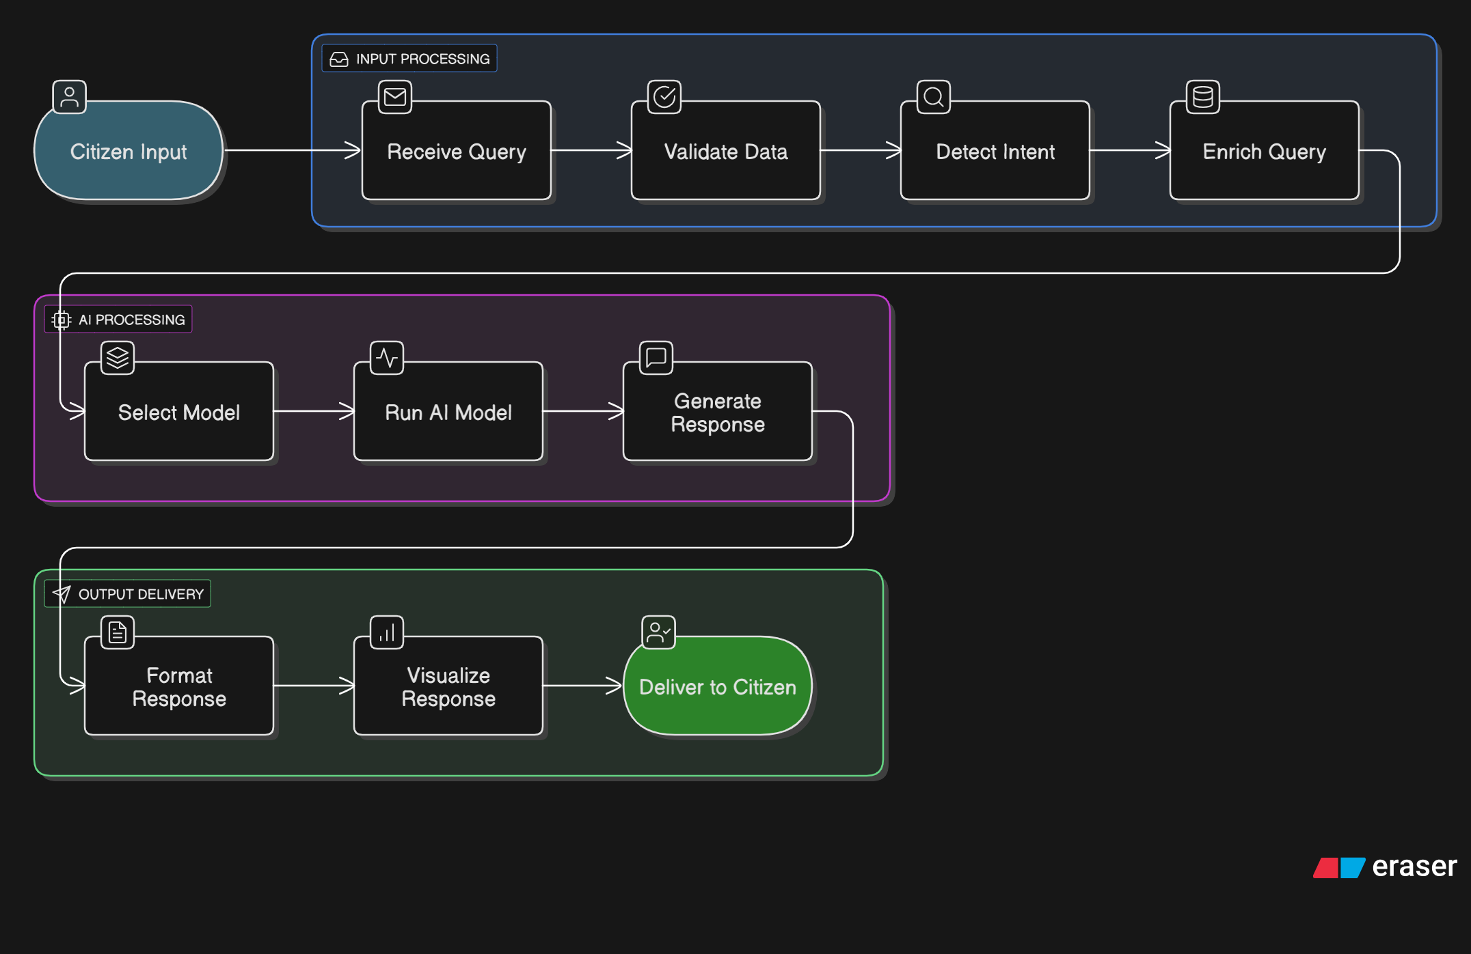

### User Stories

The following user stories represent the key functional expectations from the Citizen AI platform:

- As a citizen, I want to ask questions about government services so that I can get reliable information.  
- As a citizen, I want to receive responses tailored to my location and interests so that the information is relevant.  
- As a citizen, I want to see my conversation history so that I can refer back to previous answers.  
- As a government administrator, I want to analyze overall citizen sentiment to identify areas of concern.